Biographical Database of NAWSA Suffragists, 1890-1920
Biography of Ethel M. Armes, 1876-1945

By Rebecca Kelley, librarian, Louisiana State University, LSU Libraries, Baton Rouge, LA and Aliya Daniels, undergraduate student, University of Maryland, College Park
Journalist, author, historian, and activist in the Suffragist movement
Ethel Marie Armes was born December 1, 1876 in Washington, D.C. and died after a heart attack in Peterborough, New Hampshire on September 28, 1945. She was buried in Oak Hill Cemetery in Washington, D.C. Her parents were George Augustus Armes and Lucy Hamilton Kerr. Her father served in the Civil War where he was a colonel in the Union Army and an aide to General Ulysses S. Grant. Armes was educated in private schools in Washington, D.C.
Armes attended private schools in the Washington, D.C. area and later George Washington University, which prepared her for a career in journalism. Armes never married; she was briefly engaged to Japanese poet Yone Noguchi while still living in Washington D.C. and writing for the Washington Post. During this time, Armes was Noguchi’s editor and they often collaborated. Unfortunately, Noguchi remained unfaithful throughout the engagement and Armes broke it off in 1905 when she heard of his entanglements with other women. In 1925, Armes adopted a ten-year-old girl, Catherine Claiborne, for whom she had previously been foster parent.
Armes began her journalism career with the Chicago Chronicle in 1899 and then later with the Washington Post (1900-03). She moved to Birmingham in 1905 to join her mother and brother, George K. Armes (a civil engineer with the Louisville & Nashville Railroad), where she was hired by the Birmingham Age-Herald. Additionally, Armes wrote syndicated columns that appeared in magazines and newspapers across Alabama and the United States. In 1906, she edited the Advance Magazine.
During her time in Alabama, Ethel Armes was very active in the local and state suffragist movement. In 1911, she became a founding member of the Equal Suffrage League of Birmingham (later known as the Birmingham Equal Suffrage Association) and was elected its first vice president.
In 1912, the Birmingham Equal Suffrage Association published an impassioned invitation to “all men and women of Alabama who wish to further the cause of woman suffrage” to unite in a state suffrage organization, the Alabama Equal Suffrage Association. This call concluded with the following quote: “All over the world the cause of the enfranchisement of women is spreading far and near, from the remote provinces of Asia, throughout Europe and over America until now at last it is stirring at the heart of the Southern states. It is coming like sunrise over Alabama – a great light, sound and sweet and wholesome, born of the desire of women for a chance to help in the world’s work – for a chance to have and to deserve the rights and respect of souls.”
Armes’s experience as a journalist and writer was invaluable to both the Birmingham Equal Suffrage Association and the Alabama Equal Suffrage Association. In 1913, the Birmingham Equal Suffrage Association accepted an invitation from The Birmingham News to submit a weekly column that would include arguments for equal suffrage, as well as local suffrage news. Armes was likely involved in this collaboration and once called it “our most effective propaganda work in the press line.” Later that year Armes was appointed chairman of the Alabama Equal Suffrage Association press committee. In this capacity she wrote numerous press releases and columns that detailed suffrage work being done in cities and towns across the state. Those columns, in turn, were published in Alabama newspapers across the state.
In November 1914, Armes resigned as first vice president of the Birmingham Equal Suffrage Association, since she planned to be in Chicago for an extended visit with family. By this time, the membership in the Birmingham Equal Suffrage Association had grown to. In November 1914, Armes attended the National American Woman Suffrage Association’s Annual Convention in Nashville, Tennessee, along with a group of Alabama suffragists.

In 1914, Armes was hired by The Survey, a national social work journal, as the Alabama staff correspondent. In this capacity, she covered reform legislation in the 1915 Alabama legislative session on a variety of topics, such as child labor conditions, workers’ compensation law, and judicial system reforms.
Armes moved away from Alabama in 1917. As noted in the Jefferson County Historical Association Newsletter in 2015, her move to Boston was likely due to her “increasing dislike of industrial working conditions and her liberal social advocacy in Birmingham.” In 1920, she resided in New York City with her mother and was employed as a magazine writer. By June 1927, when interviewed by a visiting journalist from The Birmingham News, she had taken residence in Greenwich, Connecticut.
In addition to her work as a journalist and suffrage advocate, Armes was the author of several books, which required her to do extensive historical research. Her first book, Midsummer in Whittier’s Country: a Little Study of Sandwich Center, told the history of the village of Sandwich in the White Mountains of New Hampshire.
While in Alabama, Armes spent several years researching the history of its iron and coal industry, with the financial support of the Birmingham Chamber of Commerce. In 1910, she published The Story of Coal and Iron in Alabama, still in print by the University of Alabama Press. In the 2011 edition, the preface states that her book “remains the most referenced book on iron manufacture in Alabama.” As a results of her extensive research into the iron and coal industry, Armes became a vocal advocate of improving working conditions in mines and she campaigned for higher wages for miners.
Armes was able to convey her beliefs and principles through her journalism. Her Birmingham-Age Herald co-workers praised her for having a “delightfully bright and breezy [writing] style.” The style and rhetoric appealed to readers, and Armes became a renowned journalist in Alabama. She used all tools at her disposal—including interviews, speeches, letters and company records—to push for social equality in the coal mining field
In 1922, she wrote The Washington Manor House: England’s Gift to the World, which detailed the history of the George Washington’s ancestral home in Northamptonshire, England. The book was funded and published by the Sulgrave Institution, an organization that promoted friendly relations between Great Britain and the United States. Armes was elected the chairman of the executive committee of the Sulgrave Institution’s first women’s committee in 1922.
In 1928, Armes wrote Stratford on the Potomac, a book about the history of Robert E. Lee’s family home in Virginia. In 1929 she led the movement to purchase and restore Stratford Hall, the family home of Robert E. Lee, and ultimately pressed for its status as a National Historic Landmark. In 1936, she published Stratford Hall: The Great House of the Lees, which detailed both the history of the property and the restoration process. Additionally, Armes was one of five incorporators of the Robert E. Lee Memorial Foundation and held several offices, including national executive secretary and campaign director. Before her death, she had been appointed by the Garvin Institute at Yale University to conduct more research for the Foundation. In 2002, Armes was posthumously elected as an honorary director of the Board of the Foundation.

Photographs:
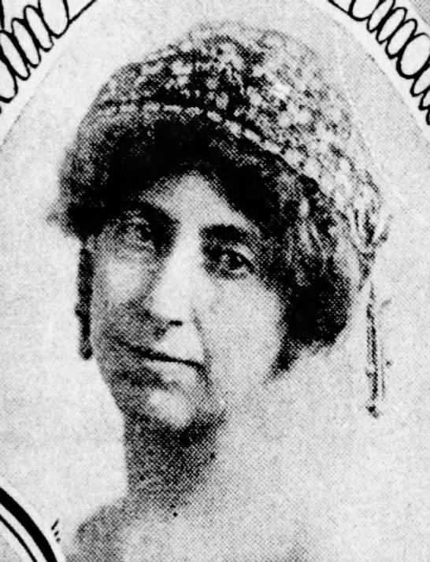
Photograph of Ethel Armes, 1912.
Lykes, Lily W. “Suffrage Day at the Alabama State Fair is Crowning Achievement of Birmingham League.” The Birmingham News. September 22, 1912, page 70.

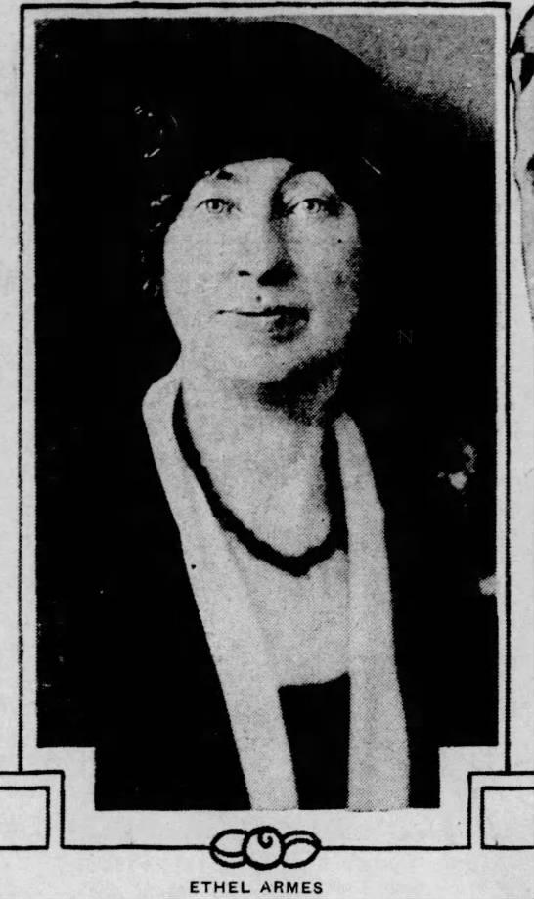
Photograph of Ethel Armes, 1928.
Chapman, Katharine H. “New York Seen From Many Angles.” The Birmingham News. June 3, 1928, page 83.

Books by Ethel Marie Armes:
Midsummer in Whittier’s Country: a Little Study of Sandwich Center. 1905.
The Story of Coal and Iron in Alabama. 1909.
The Washington Manor House: England’s Gift to the World. 1922.
Stratford on the Potomac. 1928.
Nancy Shippen: Her Journal Book. (editor) 1935.
Stratford Hall: the Great House of the Lees. 1936.

SOURCES:
“Armes, Ethel Marie, 1876-1945”. Alabama Authors. The University of Alabama University Libraries, https://www.lib.ua.edu/Alabama_Authors/?p=682.
Badham, Tom. “Ethel Armes, The Rest of Her Story.” Jefferson County Historical Association Newsletter. Spring 2015.
"Book by Miss Armes: Former Washington Girl Author of ‘Midsummer in Whittier’s Country.’” Washington Post Jul 15, 1905.
“Ethel Marie Armes.” Geni Family Tree, 9 Sept. 2019, www.geni.com/people/Ethel-Armes/6000000018657285383.
“Call to Organize Alabama Equal Suffrage Association.” The Birmingham News. September 25, 1912, page 11.
“Coal and Iron in Alabama.” The Washington Post. June 23, 1907, page 13.
Ethel Marie Armes papers, University Libraries, Division of Special Collections, The University of Alabama. Finding Aid.
“Funeral For Writer To Be Held in Capital.” The Birmingham News. October 1, 1945, page 6.
Harper, Ida Husted. History of Woman Suffrage. Vol. VI (1900-1920). New York, NY: National American Woman Suffrage Association, 1922. [LINK to AL state report]
Leonard, John William, ed. Woman’s Who’s Who of American: A Biographical Dictionary of Contemporary Women of the United States and Canada, 1914-1915. New York: The American Commonwealth Company, 1914. [LINK to Armes bio sketch]
Lykes, Lily W. “Suffrage Day at the Alabama State Fair is Crowning Achievement of Birmingham League.” The Birmingham News. September 22, 1912, page 70.
“Services Held for Miss Armes.” Tallahassee Democrat. October 4, 1945, page 12.
Stanley, C. M. “Ethel Armes Didn't Look Like a Historian.” The Montgomery Advertiser, 6 Nov. 1949, p. 17.

Stratford Hall Facebook post (March 16, 2017) – also includes photo of Ethel Armes LINK

The Birmingham News (Birmingham, Alabama). Articles from the following issues: November 13, 1911, January 5, 1913, January 19, 1913, January 26, 1913, April 27, 1913, January 25, 1914, February 4, 1914, March 15, 1914, May 24, 1914, November 8, 1914, November 10, 1914, November 22, 1914, September 1, 1916, September 30, 1916, September 9, 1917, June 3, 1928, September 29, 1945.
“The Engagement of Marriage Between Yone Noguchi...and Ethel Armes…” The Standard Union (Brooklyn, New York). August 7, 1905, page 7.
“The Home of George Washington’s ancestors…” New York Herald. December 3, 1922, page 66.
U.S. Bureau of the Census. Fourteenth Census of the United States, 1920-Population. Ancestry.com website.

